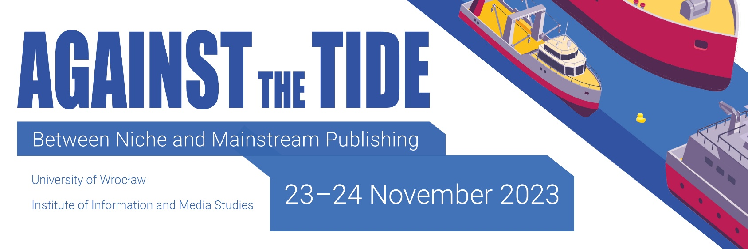

degree
author(s)
affiliation
e-mail address

Application Form

abstract
up to 300 words (including research
question, methodology, research context)

title of proposal

Page 1 of 2

selected bibliography
with academic sources
(3–5 references)

areas of interest referring to the topics listed in CFP
(up to 5 keywords)

author bio
up to 100 words

invoice details
The application should be sent by May 30, 2023 to the address konf2023inim@uwr.edu.pl

Page 2 of 2

